# Healthy Eating Test 1

Which line of Python code performs the same task as the block code below?

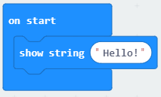

A. display.print(Hello!)

B. display.print(“Hello!”)

C. display.scroll(“Hello!”)

D. display.scroll(Hello!)

ANSWER: C

In the code below, what type of statement is the IF statement?

**if you are feeling hungry:**

**Eat some food**

**elif you are feeling thirsty:**

**Have a drink**

**else:**

**Do nothing**

A. Sequence

B. Selection

C. Iteration

D. Function

ANSWER: B

What does IDE stand for?

A. Input, Develop, Experiment

B. Input, Develop, Execute

C. Integrated Development Environment

D. Internal Development Environment

ANSWER: C

What is the name of the part of the IDE which allows you to try out your program to see if it works?

A. Error checker

B. Debugger

C. Code editor

D. Runtime Environment

ANSWER: D

The code below has been developed to show the heart icon. What command is missing?

from microbit import *

while True:

display.show(_______.HEART)

sleep(2000)

A. String

B. Icon

C. Image

D. Picture

ANSWER: C

The code below imports the microbit library. What does the * mean?

from microbit import *

A. Nothing, it is a typo

B. Import the * library from microbit

C. Import all modules from microbit

D. It allows you to add a comment to explain the purpose of the line

ANSWER: C

What is a syntax error?

A. An error in the logic of the program

B. An error which results in an unexpected output

C. An error in the code which the computer doesn’t understand

D. Anything that stops the program from producing the correct output

ANSWER: C

Which symbol is used to declare a variable?

A. +

B. :

C. #

D. =

ANSWER: D

What would be the code to produce the bottom row of LEDs in the image below?

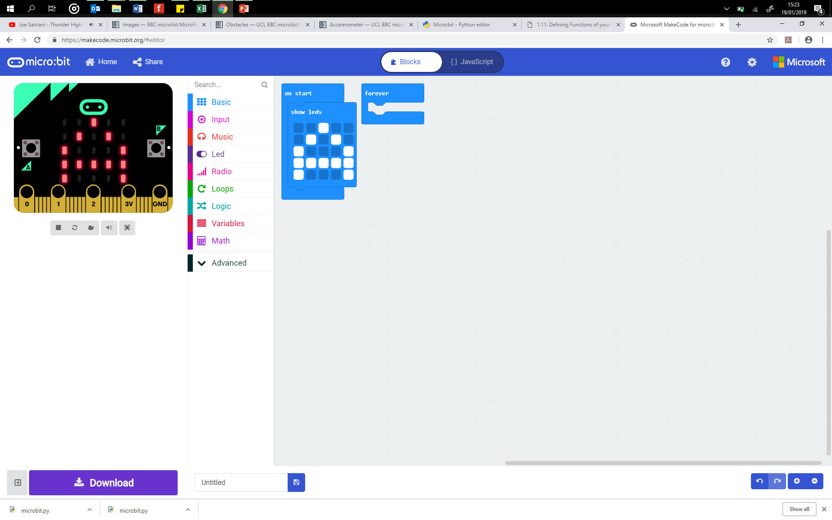

A. “90009:”

B. “90009”

C. “09990”

D. “09990:”

ANSWER: A

In the code below, what is the name of the argument?

display.show(dot1)

A. display

B. show

C. dot1

D. None of the above

ANSWER: C

A joy pad is used to control a sprite on a computer game. When you press the yellow button the sprite jumps. Which type of statement is being run?



A. Sequence

B. Selection

C. Iteration

D. Assignment

ANSWER: B

In the code below, what will appear on the screen if button b is pressed?

from microbit import *  
while True:  
 if button_a.is_pressed():  
 display.show(Image.HAPPY)  
 else:  
 display.show(Image.SAD)

A. HAPPY Image

B. SAD Image

C. Nothing

D. Error

ANSWER: B

What will the program below print?

x = 7

x = "Gareth"

x = “Hello”

x = “Goodbye”

print(“x”)

A. 7

B. Goodbye

C. x

D. 7 Gareth Hello Goodbye

ANSWER: C

Which of the pins can be used to provide power to a motor?

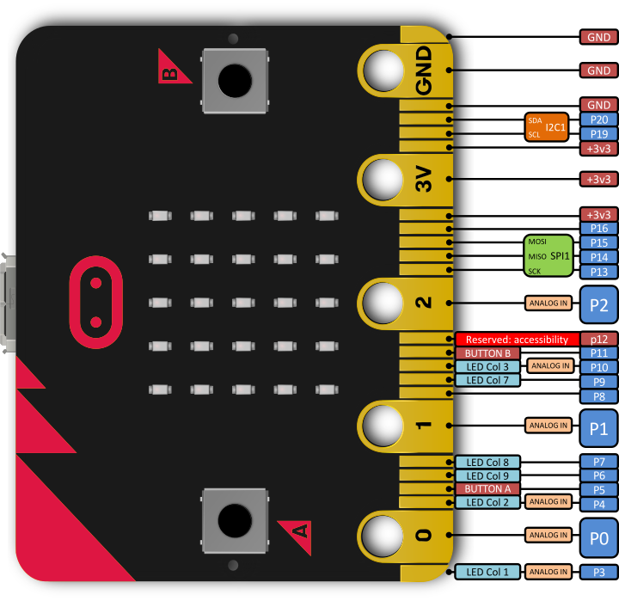

A. 1

B. 2

C. 3V

D. GND

ANSWER: C

Which image will the following code produce on the microbit?

from microbit import *

from microbit import *

pattern1 = Image (“00000:”

“09090:”

“00000:”

“90009:”

“09990”)

display.show(pattern1)

1. 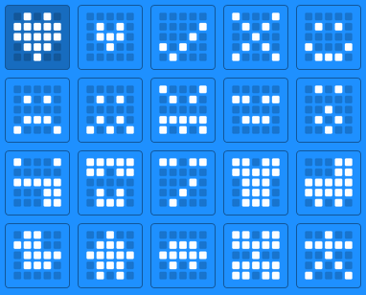
2. 
3. 
4. 

ANSWER: B

Which command can be used to delay the running of a line in a program?

A. Pause

B. Delay

C. Stop

D. Sleep

ANSWER: D

In the code below, what will happen if buttons A and B are pressed at the same time?

**from** **microbit** **import** *

**while** **True**:

**if** button_a.is_pressed():

display.show(Image.HAPPY)

**elif** button_b.is_pressed():

display.show(Image.SAD)

**else**: display.show(Image.YES)

display.clear()

A. It will display HAPPY first and then SAD

B. It will display HAPPY and SAD at the same time

C. It will display YES

D. It will cause an error to occur

ANSWER: C

What do you do when you want to end of break out of a loop?

A. Use the ‘End Loop’ command

B. Use the ‘End While’ command

C. Use an interrupt

D. Turn off the device

ANSWER: C

What will the code below output?

Num1=”2”

Num2=”3”

print(Num1+Num2)

A. 5

B. Num1 + Num2

C. 2 + 3

D. 23

ANSWER: D

Identify a variable in the code below.

from microbit import *

total = 0

while True:

if button_a.is_pressed():

total = total + 1

sleep(100)

display.scroll(total)

elif button_b.is_pressed():

total = total - 2

sleep(100)

display.show(total)

elif button_a.is_pressed() and button_b.is_pressed():

total = 0

sleep(100)

display.show(total)

else:

display.show(Image.SMILE)

A. while

B. import

C. if

D. total

ANSWER: D